Project 2: Mixed Reality Toolkit

09/09/18

CST-320

Tyler Nichols

[Introduction 2](https://docs.google.com/document/d/1WH93lYtp2_gzTW-u438KZo8vPoXNwdlbPnnvlQM_a00/edit#heading=h.f7nc8w44g3wp)

[Unity 2](https://docs.google.com/document/d/1WH93lYtp2_gzTW-u438KZo8vPoXNwdlbPnnvlQM_a00/edit#heading=h.p19ctzubctln)

[Hyper-V Configuration 2](https://docs.google.com/document/d/1WH93lYtp2_gzTW-u438KZo8vPoXNwdlbPnnvlQM_a00/edit#heading=h.p07oatu5thhb)

[HoloToolKit 3](https://docs.google.com/document/d/1WH93lYtp2_gzTW-u438KZo8vPoXNwdlbPnnvlQM_a00/edit#heading=h.atdnefyx58l1)

Loom Video 3

[HoloLens Emulator 4](https://docs.google.com/document/d/1WH93lYtp2_gzTW-u438KZo8vPoXNwdlbPnnvlQM_a00/edit#heading=h.h49izcsabrqk)

Introduction

This project is designed to ensure that all students have the required software downloaded and ready for the work ahead.

Unity

Unity was successfully downloaded and works perfectly

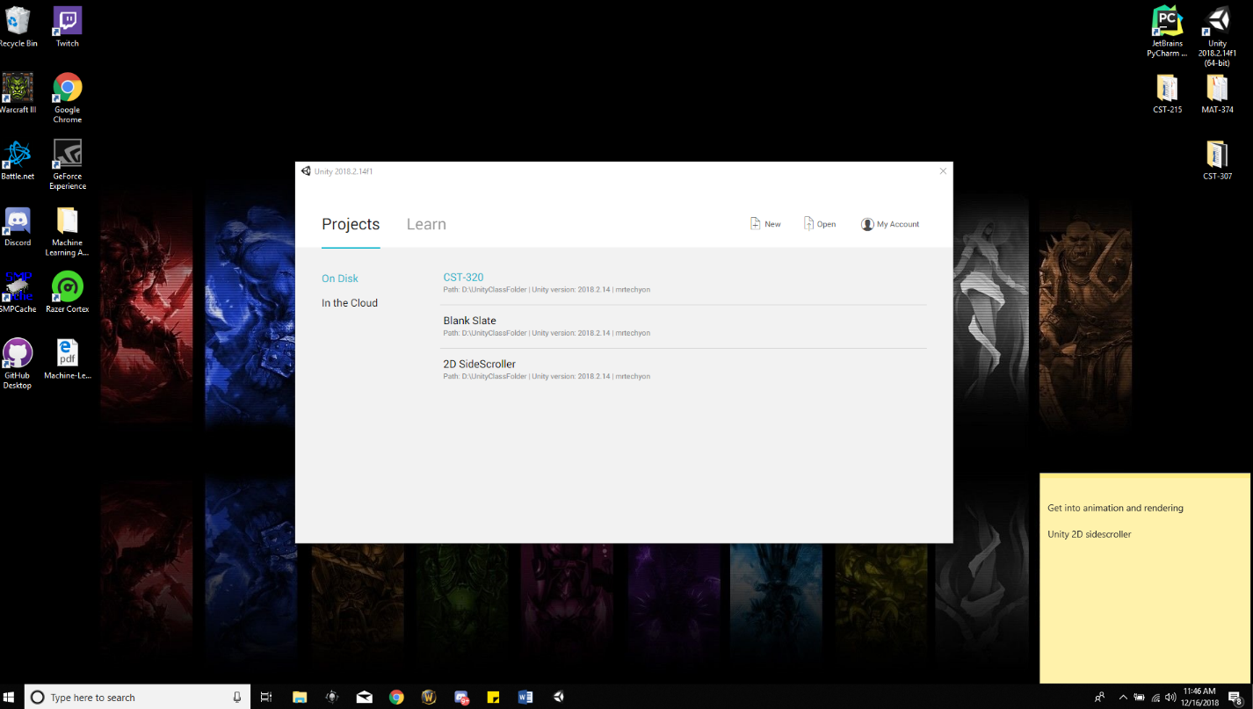

Hyper-V Configuration

This was sort of difficult to get to work because I had Education downloaded on my student email but not on my personal email would was hooked onto my computer. So I had to go through a secondary website on GCU’s website to download an additional Education license.

HoloToolKit

Downloaded the HoloToolKit from the Microsoft Windows Dev Center and the MR Input 211 folder for some additional help.

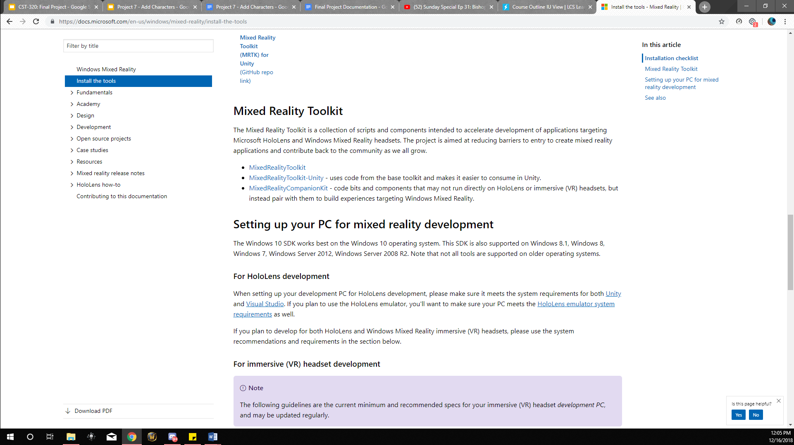

HoloLens Emulator

The HoloLens Emulator downloaded perfectly and works without a hitch. The Emulator is amazing in working with the Unity project and makes working on the project quick and efficient.

Test Program

For the test program I used the Roll-A-Ball tutorial found in the Unity website.